BIOLOGY 01
BIOLOGY F4 MID TERM CHURCH SCHOOLS JOINT – Marking scheme
1. 1@=10 marks
i | ii | iii | iv | v | vi | vii | viii | ix | x
D | D | A | C | C | E | E | D | C | B

2. 1@=5 marks
i | ii | iii | Iv | V
H | F | A | C | D

3. (i)- Mr. Kiosaki`s allele = i^{A} i^{O} (01mark)
-Mr. Kiosaki`s wife = i^{B} i^{O} (01mark)
(ii) (01mark)
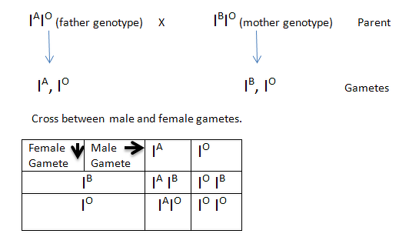
(iii) The blood groups are AB , B , A and O (01@=04marks)
(iv) 3/ 4 * 100 = 75% (01mark)
Therefore, With no blood group O is 75% (01mark)
(v) Both Mr. Kiosaki and his wife were carriers of blood group O (01mark)
4 (a) (i) Aestivation – is the torpor in summer by animals
- It is the deep sleep done by animals living in desert when the
Surroundings are too hot . (o1 mark)
(ii) Hibernation – is the torpor in winter
- It is deep sleep done by animals living in cold regions during winter
and they tend to lower even their metabolic rate to conserve energy.
(01mark)
(b) (o1/2@=5marks
Over cold surrounding | Over hot surrounding
Shivering | Sweating
Basking on heat source | Staying in shaded areas
Taking hot drinks | Taking cold drinks
Vasoconstriction | Vasodilation
Physical exercise | Swimming (in dams)

(c) A NEPHRON (Caption (01MARK)
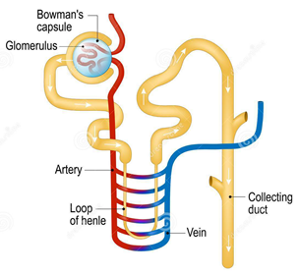
(Drawing 01/2, 4 Asked labels, 01/2 @=02marks)

5(a) (01@=04marks)
(i) To prevent air resistance when it is flying
(ii) To trap dusts and other foreign objects when enters with air
(iii) To prevent loss of water by transpiration
(iv) To increase surface area and time of absorption of nutrients
(b) ( 01@=06marks)
- Temperature – optimum temperature activates enzymatic activities
- Water – it hydrolyze food to be easily broken down by respiration
- Oxygen – it oxidizes food to release energy for growth
- Sunlight – trapped by chlorophyllic plants for photosynthesis to make organic food
- Mineral elements- macro elements uch as NPK, are very necessary for growth of plants
- Carbon dioxide – it is a raw material for photosynthesis , it is assimilated with water to
make food.
6.(a) (i) Euglena (01mark)
(ii) (01/2@=02marks)
Kingdom | Phylum
Protoctista | Euglenophyta
(iii) B (01mark)
(iv) It provides locomotory movements (01mark)
(b) (1mark@=06marks)
(i) Bacteria in brewery industry to ferment cereals making alcohols i.e wine bers etc
(ii) Bacteria in biogas production by fermenting biological wastes as done by anaerobes
(iii) Bacteria in yoghurt and cheese industry to ferment the milk to milky products
(iv) Bacteria cause diseases in animals i.e tuberculosis by mycobacterium tuberculosis
(v)Bacteria cause food spoilage - they spoils food by toxins
(vi)Bacteria destroys plants – plants pathology i.e roots rotting disease
- (a) Fermentation – is the anaerobical breakdown of food substance. Or is the breakdown of food substance in limited or absence of oxygen gas (01mark)
(b) (01@=05marks)
- Production of alcohols in brewery industries
- In bakery industry – production of breads by rising dough with help of yeast
- Production of Biogas – by fermenting biological waste
- Production of manures (Organic fertilizer) from biological waste
- In milk industry to make yoghurt and cheese
(c) (1mark@=04)
When inhales | When exhales
Ribcage pulls upward and outward (expands) | Ribcage pulls downward and inward (contracts)
Thoracic cavity volume increase | Thoracic cavity volume decrease
Intercostal muscles contracts | Intercostal muscles relaxes
Diaphragm contracts | Diaphragm relaxes and become dome shaped

8.(a) (01@=03marks)
Meiosis | Mitosis
4 haploid daughter cells are formed | 2 diploid identical daughter cells are formed
It occurs to reproductive cells | It occurs to somatic cells
It has two meiotic stages | It has one mitotic stage

8.(b) (o1@=03marks)
RNA | DNA
It is single stranded or single helix | It is double stranded or double helix
It has ribose sugar | It has deoxyribose sugar
-Its organic bases are  -Adenine  -Thymine  -Guanine  -Cytosine | Its organic bases are  -Adenine  -Uracil  -Guanine  Cytosine

(c)
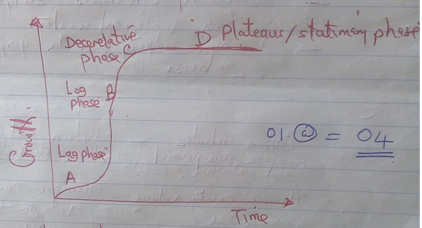
- Lag phase- cells prepare for division
- Lag phase –cells have rapid multiplication and growth is rapid
- Decerelative phase – growth is decreasing and cell multiplication decrease
- Plateaus or stationary phase – growth is constant cell division equals to cell loss

9.* Introduction (placenta ) (2.5 marks)
*main body ( roles of placenta) (02@=10marks)
-transportation of respiratory gases between foetus and maternal
-prevention of pathogens from maternal to foetus
-excretion of metabolic wastes from foetus to maternal
-secretion of hormones such as HCG (Human chorionic gonadotaphin
- can allow passage of toxic from mother to foetus i.e nicotine
*conclusion (2.5marks)

10. (i) Tuberculosis (01mark)
(ii) Mycobacterium tuberculosis (02marks)
(iii)Through air (01mark)
(iv) -At schools and colleges (01mark)
- at meetings and all overcrowded areas (01mark)
(v)-A victim should cover mouth when coughing (01mark)
-Avoid to stay in overcrowded areas (01mark)
-Keep distancing from a victim of that disease (01mark)
(vi) Give a victim with antibiotics and vaccination (01mark)

11. *Introduction ( Transpiration) (02marks)
*Main body ( advantage and disadvantage)
*Advantage of transpiration (1@=03marks)
-It cools a plants
- It allows plants to absorbs more minerals salts
-It removes toxins from plants
*Disadvantage of transpiration (1@=03marks)
- It cause witting of plants
-It can cause death of plants if in excess
-It lower photosynthesis to plants
* Conclusion (02marks)

F2- BIOLOGY (01)
BIOLOGY F2-MID TERM CHURCH SCHOOLS JOINT – Marking scheme
1. (01@=10 marks)
i | ii | iii | Iv | v | vi | vii | viii | ix | x
C | A | A | C | C | B | D | D | C | C

2. (a) (01@=05marks)
i | ii | iii | iv | v
FALSE | TRUE | FALSE | FALSE | TRUE

2. (b) (01@=05marks)
i | ii | iii | Iv | v
F | D | E | A | C
3.(a) Eukaryotic – are cells whose nuclei are bounded by nuclear membrane .They are
surrounded by two nuclear membrane called nuclear envelop
Example of Eukaryotic organism are fungi, plants animal cells (02marks)
While
Prokaryotic cell -are cells with no membrane bound nucleus . The DNA lies free in the
cytoplasm in the region known as nucleoid. Also they have no true nuclei
Example of prokaryotic organisms are bacteria 02 marks)
(b) Part found in animal cell (02@=04 marks)
(i) Cell membrane – is the thin layer that encloses the whole cell
FUNCTION ;-protects the internal organ of the animal cell
-control or allows material to go in or out of the cell
(ii)vacuoles –are fluids filled spaces bound by a membrane
FUNCTION;-secretes and excrete waste from the cell
(iii) cytoplasm –is a jell like substance made up of water and dissolve chemical substance
FUNCTION :-used as site for many chemical reaction in the cell
-maintains the shape of the cell
(iv) lysosomes
FUNCTION :-they secretes digestive enzymes in the cell
(c) Most plants cells have cellulose cell wall to prevent physical damage, cell bursting and to make plants stiff and strong (02 marks)
4(a) Waste disposal – Is the way in which we get rid of waste in our environment. (02 marks)
(b) Three basic principle of waste disposal are (03 marks)
(i) Reducing –The amounts of waste we produce must be reduced
(ii)Re-Using items –Instead of throwing them away we can use Example, we can
use an empty margarine container to store sugar.
(iii)Recycling waste items-Some waste can be changed to other products .For Example
Broken glass can be melted and used to make new glass bottles
5.(a) For people to remain healthy the following should be done (1.5@ marks)
(i) Avoid smoking
(ii) Exercise regularly
(iii) Allow time for leisure
(iv) Early well balance diet
(v) Avoid recreational drugs such as heroine and cocaine
(vi) Take medical drugs only when absolutely necessary
(vii) Drinks plenty of clean water
(b) (02marks@)
(i) Classification – is the system of grouping organism based on their similarities and
differences .
(ii)Artificial classification – is the system of classification which groups organism
according to the observable features .
Example Presence of legs or wings
(iii) Binomial nomenclature – is the scientific system of naming organism where by every
name is made up of two latine words .
(iv) Species – is a group of organism of the same individual that can produce offspring OR
-is a group of living organism consisting of similar individual which are
capable of reproduction
(v) The scientific name of dog
Canis familiaris
6.Characteristics of yeast (01@mark)
(a) They are unicellular
(b) They reproduce asexually by budding
(c) They are saprophytic
(d) Their found in colony of cells
(e) They are biocatalyst as they produce enzymes

MUSHROOM
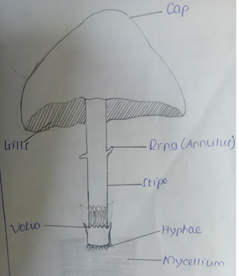
7.(a) The three modes of holozoic nutrition (01mark@)
(i) Carnivorous mode- is a mode of feeding where by organism feed on other animals.
Example Lions and hyenas
(ii) Herbivorous mode –is a mode of feeding where by organism feed on plants .
Example Rabbits and goats
(iii) Omnivorous mode –is a mode of feeding where by organism feed on both plants and
Animals Example man is omnivorous
(b) Function of Proteins (01mark@)
(i) Proteins produce enzymes which helps us to digest food
(ii) Protein forms part of cell structure and aid in the contraction of muscles.
(iii)Antibodies which are necessary for our bodies to be able to fight diseases are made of
proteins.
(iv) Proteins are major components of all the cell membrane and the play a role in the
transport of other molecules across the cell membrane.
(v) The chemical messengers in our bodies such as hormones are proteins
(vi) Proteins are source of energy in our body
(c) Nutritional disorders and nutritional deficiency (01mark@)
(i) Obesity
(ii)Anorexia nervosa
(iii) Bulimia nervosa
(iv)Marasmus
(v) Kwashiorkor
(vi) Rickets
8.(a) First Aid –is the immediate assistance given a sick or injured person before getting
Professional help. (02marks)
(b) Importance of First Aid (01mark@)
(i) It helps to sustain life
(ii) Promotes recovery to the victims
(iii)It helps to reduce pain and suffering
(iv) It reassures the victims
(v) It prevents the victims condition from being become worse
(c) You would assist a victim of electric shock as follows (01mark@)
-Turn off the source of electricity
-It not possible to turn off the electricity ,move the victim from the current source
using dry non-metallic object.
-check for signs of blood circulation ,such as breathing , coughing or movements
-If a person is not breathing , begin mouth to mouth resuscitation
-Put the person in the recovery position
-Take the person to hospital
9. Stomach is adapted to its function as follows (02marks@)
-Food enters the stomach from the oesophagus through the cardiac sphincter
-The inner wall of the stomach has gastric glands .Presence of the food in the stomach
Stimulates the production of gastric hormone from the stomach lining
-The stomach walls is made up of circular and longitudinal muscles. The muscles contract and
Relax
-The stomach wall absorb vitamins, water and drugs such as alcohol.
-The stomach`s pyloric sphincter allows small quantities of chyme to enter the duodenum at a time
SECTION C
(10 marks@ question)
10.(a) Meaning of virus -is an extremely small obligate organism

(b) Example of disease caused by virus are
(i) HIV/AIDS disease –Retrovirus
(ii) Corona disease (COVID-19)- corona virus
(iii) Common cold
(iv) Ebola
(v) Influenza – influenza virus
(vi)Measles
(vii) Chickenpox
(viii)Genital herpes

(c) * Advantage of virus
- Viruses are important in the study of cellular and molecular biology
- Bacteriophage are viruses that attack bacteria
-Viruses are used in the study of biological weapons
-Some viruses are used to make vaccine
*Disadvantages of viruses
-Viruses are pathogens means they cause disease
-They destroy living cells
-Viruses can reproduce very fast , leading to large scale-epidemics
-Viruses can alter themselves often and thus become difficult to destroy
11.(a) Meaning of stomach ulcers – is a burning or gnawing pain in the centre of the abdomen
OR -Is a sore in the stomach lining which is caused by the erosion of
the stomach`s mucus coating
(b) Cause of stomach ulcers
(i) Bacteria called HELICOBACTER PYLORI
(ii) Certain medication like asprin
(iii) Smoking ,Alcohol and Caffeine
(c) Signs and symptoms of stomach ulcers are
-Nausea and vomiting
-Tiredness and weakness
-Burning pain in the stomach
-Blood in vomit or stool
-Heartburn
-Feeling of fullness , bloating or bleaching

(d)
-Prevention of stomach ulcers
-Stomach ulcers can be controlled or treated by using medication
-Avoid smoking and taking alcohol and caffeine
-Avoid taking acidic foods because they irritate stomach ulcers
-Limiting your use of some drugs like ibuprofen, asprin and naproxen

MID TERM CHURCH SCHOOLS JOINT EXAM
F4-BIOLOGY 2A PRACTICALS
MARKING SCHEME
- (03@=15marks)
(i) Sensitivity or irritability
(ii) Hotness
(iii) Skin
(iv) Thermo-receptors
(v)Reflex action

Drawing=02marks
Labeling 02marks
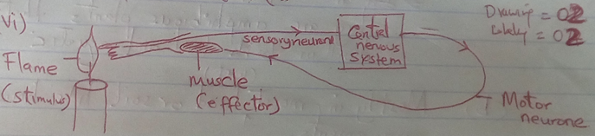
(03@=06marks)
(vii)Reflex arc
(viii)Stimulus
2.(i) (01@=04marks)
F | G | H | I
Moss plant | Fern plant | Mushroom | Bean seed

(ii) (001/2@=06marks)
 | KINGDOM | PHYLUM | CLASS
F | Plantae | Bryophyta | Music
G | Fungi | Filicinophyta/pteridophyta | Filicopsida
H | Plantae | Basidiomycota | Agaricomycetes
I | Plantae | Angiospermophyta | Dicotyledonae

(iii) A DIAGRAM OF SPECIMEN ( I )
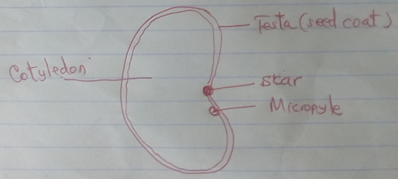
Title=01mark)
Drawing=(01mark)
Labeling 4 parts= (04marks)
(iv) (01@=09marks)
–it is a food
-it is ecologically useful
- its plant produces oxygen for animals
- it is used in biological research to study different systems and anatomies of plants
(v) (a) –They have false leaves stem and roots , roots are called rhizoids
-They are amphibious plants that dwell in both land aquatic
(b) Mostly in moist (wet) land like house pavements
(c) -It lack chlorophyll, cannot undergo photosynthesis
-Its cell wall made up of chitin instead of cellulose .

